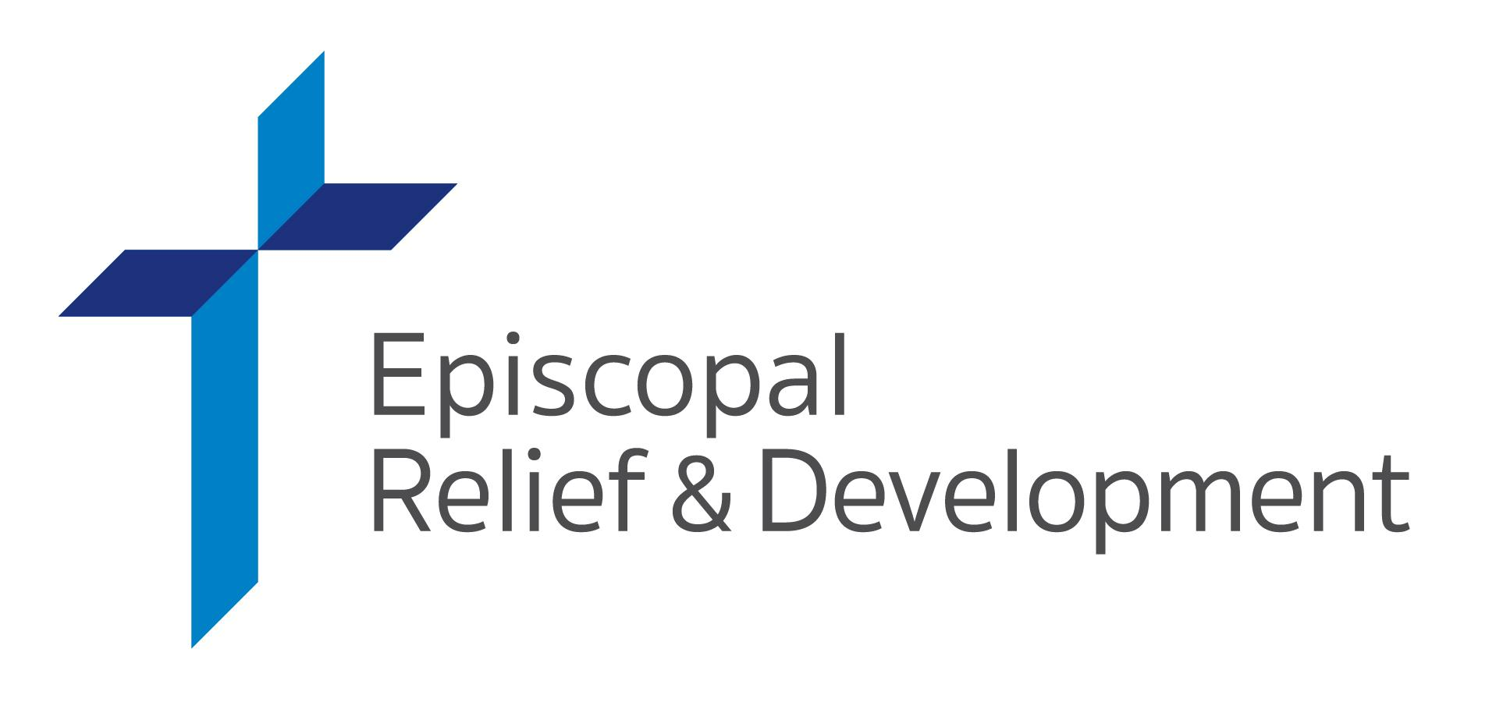

COME TOGETHER FOR LASTING CHANGE

One of the greatest joys of being in a community is the impact we can make together. Gifts for Life is one simple, meaningful way to gather our congregation in faithful service.

[Customizable paragraph to inform your congregation about what your members are doing for Gifts for Life. Example: Betty C. is hosting a garage sale! Join her at [date, time, address for activity.]

Now, more than ever, we remember the intrinsic value of our relationships with one another – and that our collective action has the capacity to enact great change. What seed of generosity and compassion will your community plant with Gifts for Life this year?

Since 1940, Episcopal Relief & Development has been helping facilitate transformative, lasting change worldwide. When working alongside communities and our network of partners, Gifts for Life have the power to make a tangible difference. These symbolic gifts are based on the three key priorities of community development that have proven to be most effective in our 80+ years of faith-based work.

Ensure access to the most crucial element of health and resistance with Clean Water… Provide information, medicine and nutrition for new families with Care for Moms & Newborns… Offer sustainability with a Goat… or give a variety of key items from our gift categories to empower an entire community with a Complete Care Package. Gifts for Life have the power to make a real, lasting difference in the lives of our brothers and sisters worldwide.

Visit episcopalrelief.org/gifts or scan our QR code to browse, purchase and learn more about Gifts for Life online.

